Unit 1.3 File Compression (Class Activity Answers)

1 a) What is meant by lossless and lossy file compression?
Ans: lossless: compression method that enables the original file to be restored following decompression (eg: TIFF, BMP, PCX).

Lossy File Compression: compression method where parts of the original file cannot be recovered during decompression, so some of the original detail is lost. The algorithm used in the lossy technique needs to decide which part of the file are to be kept and which are to be discarded (eg: MP3, JPEG).

b) Give an example of a lossless file format and an example of a lossy file format.
Ans: Lossless file compression (eg: TIFF, BMP, PCX).
Lossy file compression ((eg: MP3, JPEG)

2 a) What is meant by run length encoding?
Ans: A form of lossless / reversible file compression that reduces the size of a string of adjacent, identical data (such as repeated colours in an image). It can be used to compress a number of different file formats (eg: tiff, bmp. pcx).

b) Describe how RLE compresses a file. Give an example in your description.

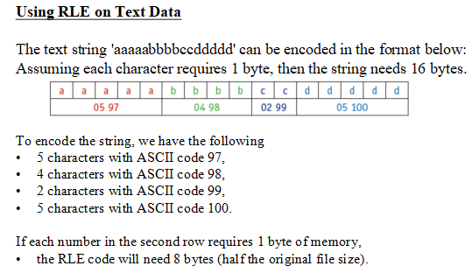

3) With reference to the following data input:
WWWWWWWWWWWWBWWWWWWWWWWWWBBBWWWWWWWWWWWWWWWWWWWWWWWWBWWWWWWWWWWWWWW

What is the ouput of the RLE encoded data ?
Ans: 12W1B12W3B24W1B14W

- Write down the RLE coded data for the following image
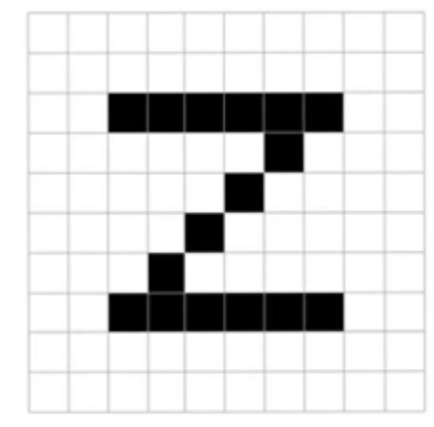

Ans:

Ans: 